**Meeting:** Tenth Official Sponsor Meeting

**Date:** 16th September 2016

**Location:** B3 Bistro

**Attendees:** Wendy, Weilun

Edmund, Marcus

**Absentees:** Gao Min, Zong Wei, Chingyi

**Minutes Prepared by:** Wendy

**Vetted by:** Weilun

**Points to Note**

1. Went through the expert testing II feedbacks

**Minor**:

Profile tab can’t be view probably due to old account

Scroll for registration

**UI**:

Main page: background color for button

Update record:

Delete button change to delete entire records

Edit pop up add new record message: Successfully Saved /n Please continue.

Shift sales – this month to analytics, show today’s figures, this week’s figures and this month’s figures

**Report**: bold net profit line and legend to be consistent with the above text

**Tax:**

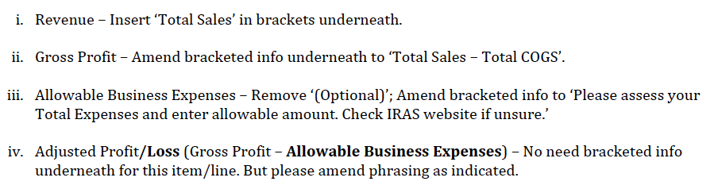

**Function**:

report starts from week

**Calendar**: add profit, lock the days in calendar

**Profile**: please fill in incomplete field at the tab with red dot, successful alert

**Sync**: successful alert, sync even before enter admin pin, CHECK SYNC FUNCTION!!!

Check for clearance of login details

Analytics: comparison

1. Unique testing builds in xcode
2. Client approved changing function name from Analytics Module to Business Intelligence (BI) Module
3. Discuss and decided to do the parse migration with the help of Marcus at Iteration 10

Meeting is adjourned at **1515**.